[1]

Vishwakarma Institute of Technology, Pune 411037, Maharashtra, India

**ROAD LANE-DETECTION BASED ON HEURISTIC ALGORITHM**

Guide Name: Prof. Tejaswini Bhosale

Pankaj Kamble 12011219, Nabil

Patel 12011081, Sarthak

12011007, Isha Pathak

12010341, Anjali Patil 12010332

pankaj.kamble20@vit.edu, nabil.patel20@vit.edu,

sarthak.pagar20@vit.edu, isha.pathak20@vit.edu, anjali.patil20@vit.edu

*Abstract* — ***In this paper, a lane-line identification and tracking approach that is both quick and reliable is suggested. The suggested method is well-suited for usage in ADAS or self-driving automobiles. The suggested approach focuses on simplicity and quick calculation capabilities so that it may be implemented in low-cost CPUs used in ADAS systems. The suggested method consists mostly of a pipeline of computer vision algorithms that complements one another and takes in raw RGB photos to generate the requisite lane-line segments that reflect the car's road boundaries. Each algorithm is thoroughly documented and implemented, and its performance is assessed using actual road photos and movies acquired by the car's front-mounted camera. Real-world videos are used to test and assess the entire pipeline's performance. The suggested approach is shown to consistently recognize and track road borders under a variety of scenarios in the assessment.***

***We provide a strategy for detecting information about lanes and cars for the driver assistance system. Earlier studies could only detect individual lanes or cars. The combination of lane information and vehicle information, can help the driver aid system or lane change assistant system work more reliably. The frontal lanes must be detected and the cars around a test vehicle must be discovered for the lane change assistant system (LCAS).***

***As a result, in this investigation, a vision system with three cameras is used, two of which are mounted beneath the right and left-wing mirrors, while the other is mounted on the test vehicle's windscreen. Three lanes and cars are detected using the footage from the cameras.***

*Keywords — Road Lane Detection, open CV, Machine Learning, Data Science, Algorithms, Methods*

# INTRODUCTION

The annual increase in car ownership has caused traffic safety to become an important factor affecting the development of a city. To a large extent, the frequent occurrence of traffic accidents is caused by subjective reasons related to the driver, such as drunk, fatigue, and incorrect driving operations. Smart cars can eliminate these human factors to a certain extent. In recent years, the development of smart cars has gradually attracted the attention of researchers in related fields worldwide. Smart cars can intelligently help humans perform driving tasks based on real-time traffic information, thereby indicating their significance in improving the safety of automobile driving and liberating human beings from tedious driving environments. Lane detection is an important foundation in the course of intelligent vehicle development that directly affects the implementation of driving behaviors. Based on the driving lane, determining an effective driving direction for the smart car and providing the accurate position of the vehicle in the lane is possible; these features contribute significantly towards improving the efficiency and driving safety of automatic driving. Actuated detection of lane roads is a critical issue in lane detection and departure warning systems. If an automobile crosses lane confinement then vehicles enabled with predicting lane borders system direct the vehicles to prevent collisions and generate an alarming condition. This kind of intelligent system always makes the safe travel but it is not always necessary that lane boundaries are clearly noticeable, as poor road conditions, and inadequate quantity of paint used for marking the lane boundaries make it hard for the system to detect the lanes with accuracy and other reasons can include environmental effects like shadows from things like trees or other automobiles, or street lights, day and night time conditions, or fog occurs because of invariant lightning conditions. These factors cause the problem to distinguish a road lane in the backdrop of a captured image of a person. In order to deal with the above-stated problems arising due to changes in lane boundaries. The algorithm followed in this paper is to detect lane markings on the road by giving the video of the road as an input to the system by using computer vision technology and primarily designed with the objective of reducing the frequency of accidents. The system can be installed in cars and taxis in order to prevent the occurrence of accidents due to reckless driving on the roads. School buses will guarantee the safety of the children. Moreover, the performance of the driver can also be monitored, Road Transportation Offices can use the setup to check and report the negligence of drivers and lack of attention on the roads. A Live Lane-Line Detection Systems built-in Python language is another Data Science project idea for beginners. A human driver receives lane detecting instruction from lines placed on the road in this project. The lines placed on the roads indicate where the lanes are located for human driving. It also refers to the vehicle’s steering direction. This application is crucial for the development of self-driving cars. This application for the Data Science Project is critical for the development of self-driving cars.

A lane detection algorithm for intelligent vehicles in complex road conditions and dynamic environments was proposed. Firstly, by converting the distorted image and using the superposition threshold algorithm for edge detection, an aerial view of the lane was obtained by using region of interest (ROI) extraction and inverse perspective transformation. Secondly, based on the curve model, the random sample consensus (RANSAC) algorithm was adopted to fit the curves of lane lines, and the fitting evaluation and the curvature radius calculation on the curve were then carried out. Lastly, by using the road driving video under complex road conditions and the Tusimple dataset, simulation test experiments for lane detection algorithms were carried out. By analyzing the experimental results and comparing them with other algorithms, the comprehensive performance of the algorithm was evaluated.

# Literature Review

In order to exhaustively exploit information on input images and to decrease computational complexity, horizon line, and adaptive ROI are defined and used to ensure reliable real-time system. And also we have Vision-based lane detection systems are reviewed from three aspects, namely, algorithms, integration, and evaluation methods. The Approaches that adopt conventional computer vision techniques are reviewed and compared according to the separate functional modules in a generic framework

# Methodology/Experimental

**HOUGH TRANSFORMATION**

The Hough transform is a [feature extraction](https://en.wikipedia.org/wiki/Feature_extraction) technique used in [image analysis](https://en.wikipedia.org/wiki/Image_analysis), [computer vision](https://en.wikipedia.org/wiki/Computer_vision), and [digital image processing](https://en.wikipedia.org/wiki/Digital_image_processing). The purpose of the technique is to find imperfect instances of objects within a certain class of shapes by a voting procedure. This voting procedure is carried out in a [parameter space](https://en.wikipedia.org/wiki/Parameter_space), from which object candidates are obtained as local maxima in a so-called accumulator space that is explicitly constructed by the algorithm for computing the Hough transform.

**CANNY EDGE DETECTION**

Canny Edge Detection is a popular edge detection algorithm. It is a multi-stage algorithm and we will go through each stages. Noise Reduction. Since edge detection is susceptible to noise in the image, the first step is to remove the noise in the image with a 5x5 Gaussian filter.

**GAUSSIAN BLUR**

In [image processing](https://en.wikipedia.org/wiki/Image_processing), a Gaussian blur is the result of blurring an [image](https://en.wikipedia.org/wiki/Image) by a [Gaussian function](https://en.wikipedia.org/wiki/Gaussian_function). It is a widely used effect in graphics software, typically to reduce [image noise](https://en.wikipedia.org/wiki/Image_noise) and reduce detail. The visual effect of this blurring technique is a smooth blur resembling that of viewing the image through a translucent screen, distinctly different from the [bokeh](https://en.wikipedia.org/wiki/Bokeh) effect produced by an out-of-focus lens or the shadow of an object under usual illumination.

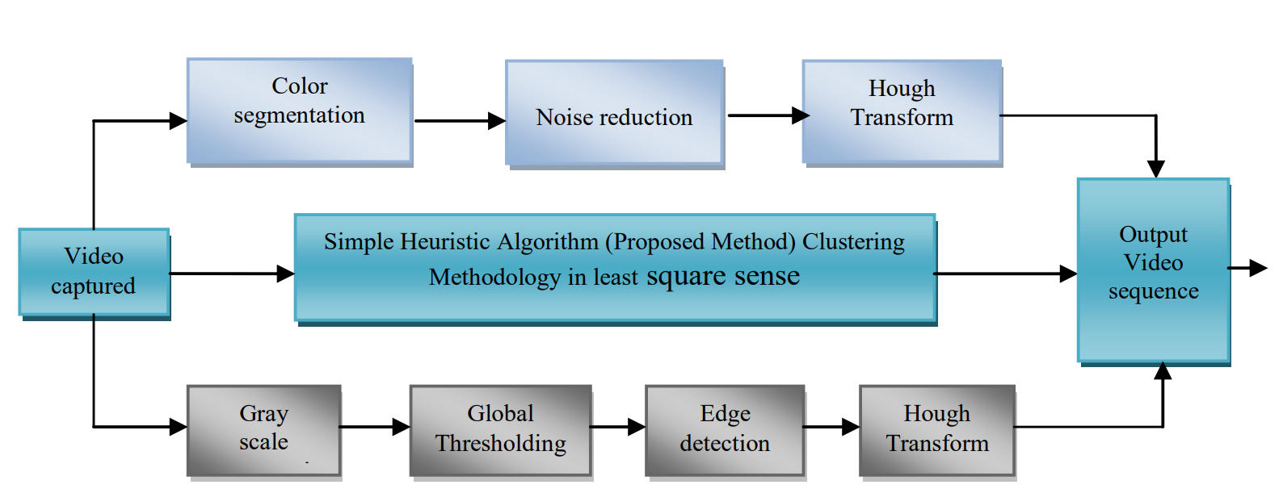Gaussian smoothing is also used as a pre-processing stage in [computer vision](https://en.wikipedia.org/wiki/Computer_vision) algorithms in order to enhance image structures at different scales.

# Results and Discussions

Robust lane detection is an important application of Intelligent Transport Systems. In the case of lane detection, we described and implemented the Hough-based detection, and had a look at the results. We saw that the Hough-based algorithm is not efficient enough and some lines were not detected. Then, we described the color-based detection algorithm and extracted some more information about lines based on their color information to make Hough-based detection more efficient.

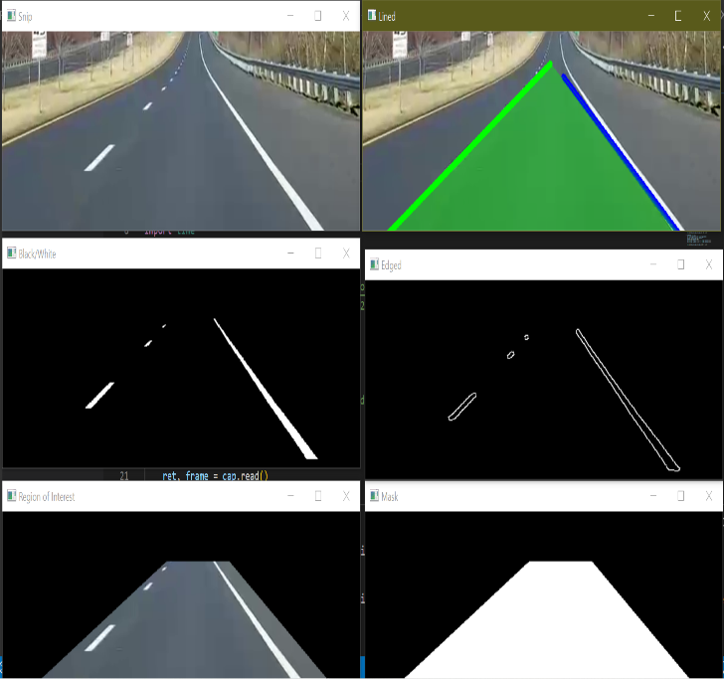

# AlGORITHM

Introduction with increasing traffic density, the demand for higher security and greater comfort for the car driver arises. Therefore new technologies are required. One of these is computer vision, which can be used to support the driver in complex situations in order to increase his security and comfort. A possible function to be used in future driver support systems is automatic object and lane marker detection. For these applications, active sensors like radar show significant problems in the near vicinity of the sensor. As an alternative, video can be applied for object detection, which is the subject of this paper. Discovering markers road lanes in a noisy video stream captured by the camera mounted on the car in a cloudy environment where it is difficult to recognize white lines on the road to stay in exact lanes due to wrong-way lane detection, many researchers and companies car introduce Intelligent transport systems (ITS) work with smart infrastructure towards having safer environment and reduce traffic problems. This fact helps us to embed a system driver assistant in the vehicle to keep the vehicles on the track and prevent road leaves. Analyzing an image or a few images as frames of a video to mark the lane is called Lane detection, which provides information to the embedded intelligent systems that track lanes and steer the vehicle. There are many methods for lane detection in which one of the methods is to use the SP line and equalize the SP line. These methods model lanes by dividing the captured image into any sub-images. The second method is to use an artificial vision-based lane detection using the Hough transform and linear parabolic installation. As we mentioned, there are many methods implemented for lane discovery two of them are Hough-based detection, and color-based detection. Hough-based detection and Color-based detection are effective, but there are some problems when we use them individually to detect unwanted lines or not detect any existing lines of Hough-based detection and sensitive to the scene condition for Color-based detection. One of the main pre-processing steps of these types of applications is lane detection. We have developed a simple heuristic method for the detection of lanes in the video. The method starts by thresholding each frame (or a combination of the current frame with the previous one) by keeping only the brightest regions of the image. Some of the detected regions are then eliminated having as a basis some properties like area, orientation, and eccentricity. A clustering methodology is used to group the detected points and the best fit line (in the mean squares sense) is then fitted to the remaining points. In order to check the coherence of the retrieved lines, some checks are made. Lines that are too close are merged; if more than 4 lines are detected, the 4 most similar to the ones detected in the previous frame are kept; if there are big jumps in the lines from one frame to the next ones, the corresponding line is eliminated; and if less than 4 lines are detected, lines from the previous frame are retrieved. Finally, if the lines are not being updated for 12 frames they are either not displayed (in the case of the outside lanes) or the line is replaced with a line between the two adjacent lines (in the case of the inside lanes

# Future Scope

In future work, a formal evaluation of the performance should be made. Moreover, the robustness of the algorithm will be tested by applying it to other video sequences. Another line of work would be to generalize the lane detection to curves.

# Conclusion

We provide a strategy for detecting information about lanes and cars for the driver assistance system. Earlier studies could only detect individual lanes or cars. The combination of lane information and vehicle information, can help the driver aid system or lane change assistant system work more reliably. The frontal lanes must be detected and the cars around a test vehicle must be discovered for the lane change assistant system (LCAS).

As a result, in this investigation, a vision system with three cameras is used, two of which are mounted beneath the right and left-wing mirrors, while the other is mounted on the test vehicle's windscreen. Three lanes and cars are detected using the footage from the cameras.

References

[1] Analysis of lane detection techniques using OpenCV **2015**

[**Sunil Kumar Vishwakarma**](https://ieeexplore.ieee.org/author/37088285057)**;** [**Akash**](https://ieeexplore.ieee.org/author/38667394100)**;** [**Divakar Singh Yadav**](https://ieeexplore.ieee.org/author/38231565100)

[2] Lane-line Detection Algorithm for Complex Road Based on OpenCV **2019**

[Zaiying Wang](https://ieeexplore.ieee.org/author/37898314300); [Ying Fan](https://ieeexplore.ieee.org/author/37087473396); [Hao Zhang](https://ieeexplore.ieee.org/author/37086953330)

[3] Flexible lane detection using CNNs **2021**

[**Li Haixia**](https://ieeexplore.ieee.org/author/37679664600)**;** [**Li Xizhou**](https://ieeexplore.ieee.org/author/37088900625)

[4] Smart City Lane Detection for Autonomous Vehicle **2020**

[**Edward Swarlat Dawam**](https://ieeexplore.ieee.org/author/37086329946)**;** [**Xiaohua Feng**](https://ieeexplore.ieee.org/author/37086264484)

[5] The Implementation of Lane Detective Based on OpenCV **2010**

[**Wu Ye**](https://ieeexplore.ieee.org/author/37864543200)**;** [**Shan Yuetian**](https://ieeexplore.ieee.org/author/37856852600)**;** [**Xu Yunhe**](https://ieeexplore.ieee.org/author/37856849900)**;** [**Wang Shu**](https://ieeexplore.ieee.org/author/37858078200)**;** [**Zhuang Yuchen**](https://ieeexplore.ieee.org/author/37863869500)

[6] A novel illumination-invariant lane detection system **2020**

[**Mehrez Marzougui**](https://ieeexplore.ieee.org/author/38563374300)**;** [**Belgacem Bouallegue**](https://ieeexplore.ieee.org/author/37296885800)**;** [**J. Subash Chandra Bose**](https://ieeexplore.ieee.org/author/37086384625)**;** [**Paul Rodrigues**](https://ieeexplore.ieee.org/author/37086051168)**;** [**Mohamed Atri**](https://ieeexplore.ieee.org/author/37442372300)

[7] Lane detection system with around view monitoring for the intelligent vehicle **2013**

**Kum C.H., Cho D.C., Ra M.S., Kim W.Y.**

1.